 | 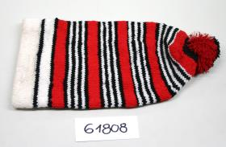
Inventory Number: | RJM 61808
Other number:
Title: | Cap
Artist/Participant: | Yoruba; Cultural attribution
Provenance: | Nigeria
Date:
Material/Technique:
Dimensions: | "Object dimensions: H 390 x W 200 x D/L 55 mm Weight: 110 g"
Location:
Acquisition manner:
Acquisition through:
Acquisition by:
Year of acquisition:
Acquisition note:
Description:
Notes:
Literature:

Weitere Bilder
Bild

